Supplementary Tables and Figure

Supplementary Table 1. Genomic location for 147,888 identified MHBs with 61 WGBS dataset.

Supplementary Table 2. Genomic location for 1360 tissue specific MHB regions which was applied in random forest model.

Supplementary Table 3. Layer specific MHL regions and the layer specificity index.

Supplementary Table 4, 5, 6. 4738, 4307 and 5428 significant different MHL regions between colon, lung as well as pancreatic cancer plasma and normal plasma.

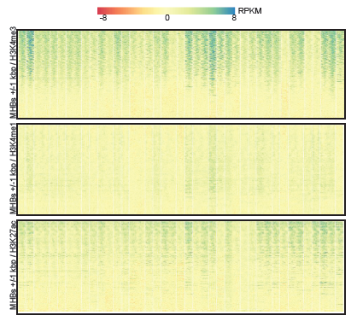

Supplementary Figure S1. MHBs enrichment of MHBs in H3K4me3 and H3K27ac regions. The columns are 41 different human cell types. Histone maps of H3K27ac, H3K4me1, and H3K4me3 from the Roadmap Epigenomics Project.

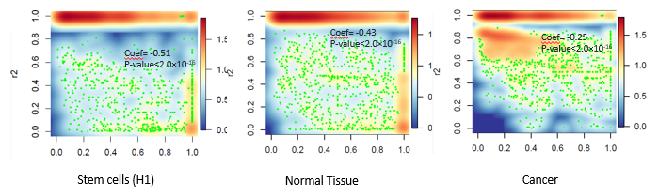

Supplementary Figure 2. Relationship between R2 and Relative Distance between Pair-wise CpGs (adjusted by length of MethyBlock). We can find Linkage disequilibrium (R2) begins to decay from very nearby neighbor CpGs therefore the decay coefficient is large than normal and stem cells. In contrast, stem cell and normal seems to decay at far CpGs therefore the decay coefficient is smaller.